

NISHAT GROUP

D.G. KHAN CEMENT COMPANY LIMITED

**Factory:** Khofli Sattai, Dera Ghazi Khan - Pakistan Tel: (+92-641) 460025-7 Fax: (+92 - 6410 460028 / 462392 e-mail: dgksite@dgcement.com

**E X P E R I E N C E C E R T I F I C A T E**

**TO WHOM IT MAY CONCERN**

It is to certify that Mr. <Name> S/o <fname> has worked in this company D.G. Khan Cement Pvt. Ltd. From <From> to <To>.

He has worked as a <Designation>. During his stay with us we found him innocent, efficient and hardworking person.

We pray for his success in his future life.

With best wishes.

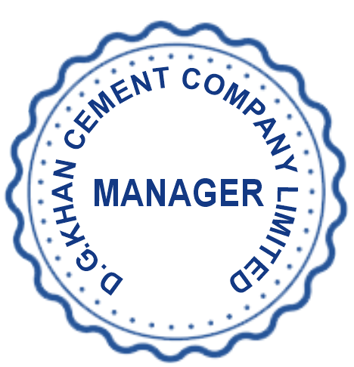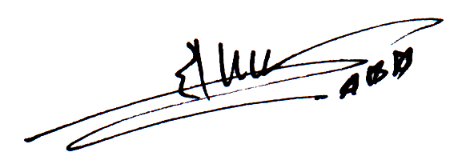

(Zahid Aziz)

From Manager D.G Khan Cement (Pvt.) Ltd.

Head Office: **Nishat House, 53-A, Lawrence Road, Lahore - Pakistan Tel: (+ 92-42) 6367812 / 6311526 Fax: (+92-42) 6367414 E-mail: info@dgcement.com**